### Helpful Notes:

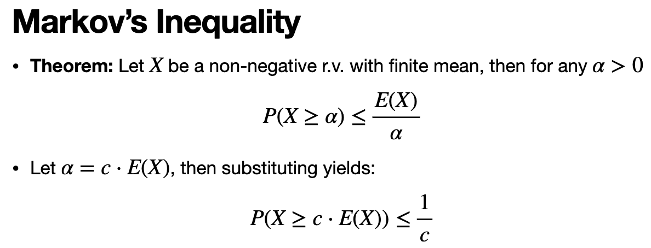

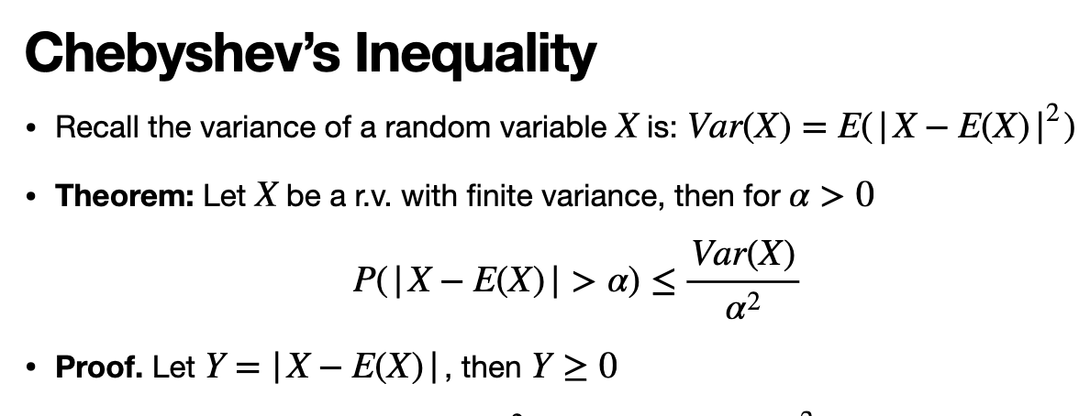

Note: Chebyshev’s assumes pairwise independence

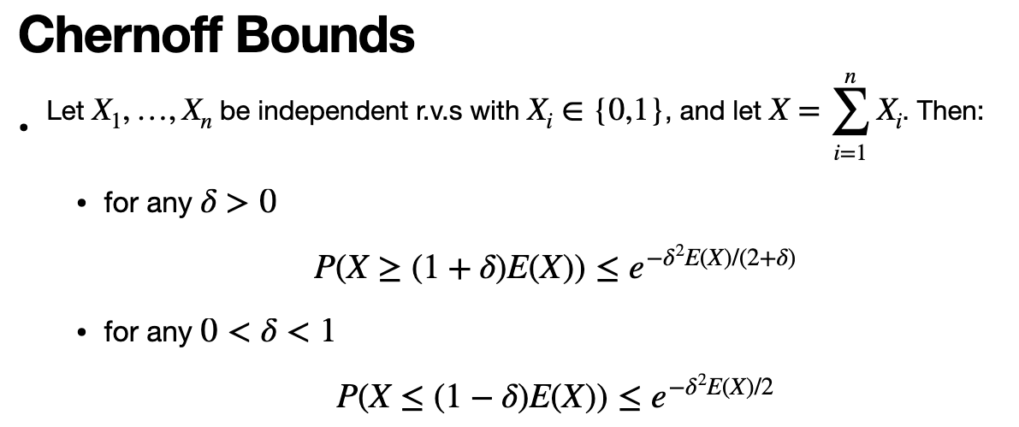

### Solution 1a.

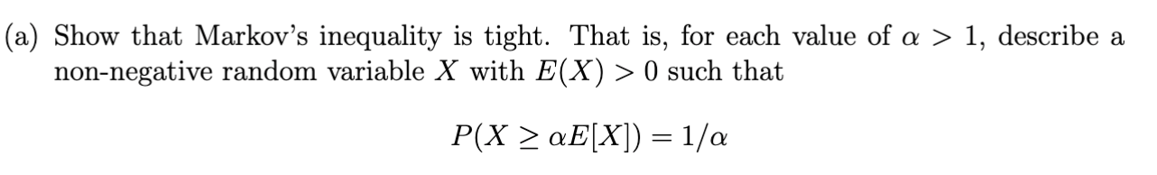

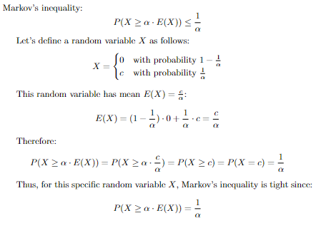

### Solution 1b

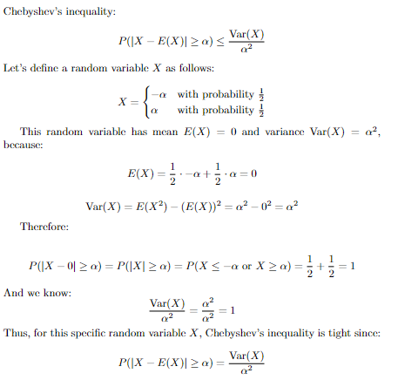

### Solution 2.

**Sol:** Restart after 5 minutes. By Markov’s inequality, the probability the algorithm runs past 5 seconds is at most 1/5, and we get 2 5- minutes runs in the 10 minutes time budget, so the probability we don’t get a solution is the probability that both the first and second run take more than 5 minutes, namely 1/5^2 . Therefore, getting an answer within the 2 5 minute runs is 1-1/5^2.

### Solution 3a.

Describe a set of hash functions that is uniform but not universal

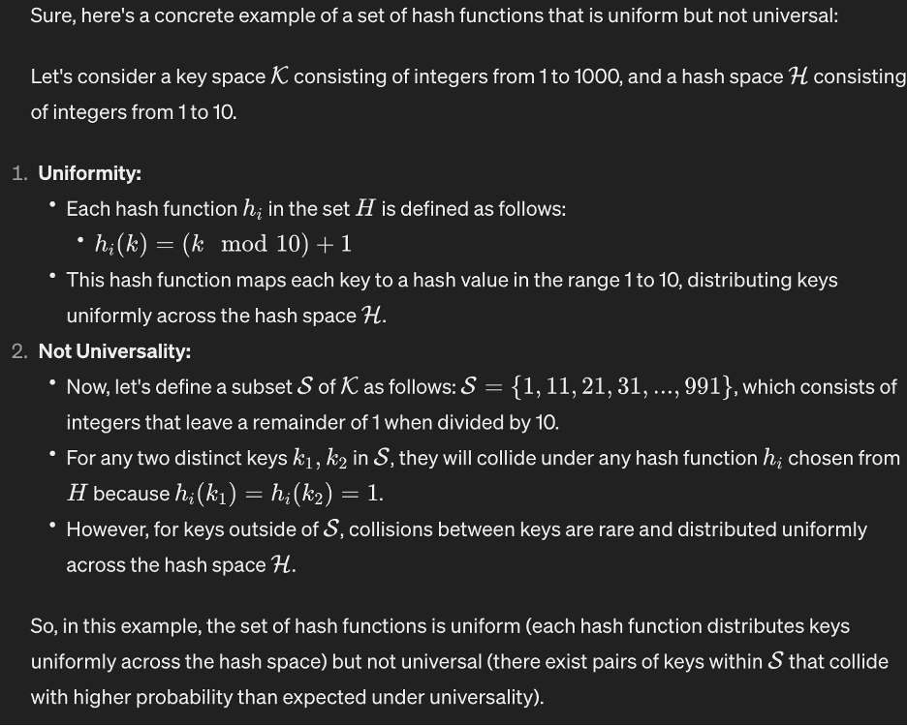

Solution 3b.

Describe a set of hash functions that is universal but not uniform.

